

Lab Journal: 04
Date: 10/14/2025

Student : Lotfullah Muslimwal
Enrollment : 01-131232-039

Department of Software Engineering

Bahria University, Islamabad

Software Construction-Lab (Fall-2025)
Teacher: ENGR. SAAD MAZHAR

Task No: | Task Wise Marks |  | Documentation Marks |  | Total Marks  (20)
Task No: | Assigned | Obtained | Assigned | Obtained | Total Marks  (20)
1 | 3 |  | 5
2 | 3 |  | 5
3 | 3 |  | 5
4 | 3 |  | 5
5 | 3 |  | 5

Comments:

Signature

Lab 04 – Using Maps for Associations and Using Library Classes

GitHub Repo: Lab 4 Code

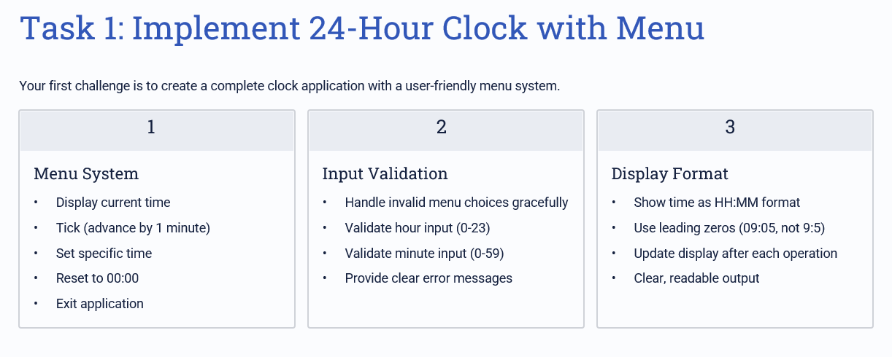
Code for Task 1

import java.util.Scanner;

public class Task1 {

private int hour;

private int minute;

public Task1() {

hour = 0;

minute = 0;

}

public void showTime() {

System.out.printf("%02d:%02d%n", hour, minute);

}

public void tick() {

minute++;

if (minute >= 60) {

minute = 0;

hour++;

if (hour >= 24) {

hour = 0;

}

}

}

public void setTime(int h, int m) {

if (h >= 0 && h < 24 && m >= 0 && m < 60) {

hour = h;

minute = m;

} else {

System.out.println("Invalid time.");

}

}

public void reset() {

hour = 0;

minute = 0;

}

public static void main(String[] args) {

Scanner sc = new Scanner(System.in);

Task1 clock = new Task1();

while (true) {

System.out.println("\n1. Show Time");

System.out.println("2. Tick (Add One Minute)");

System.out.println("3. Set Time");

System.out.println("4. Reset");

System.out.println("5. Exit");

System.out.print("Choose: ");

int choice;

try {

choice = Integer.parseInt(sc.nextLine());

} catch (Exception e) {

System.out.println("Invalid choice.");

continue;

}

if (choice == 1) {

clock.showTime();

} else if (choice == 2) {

clock.tick();

clock.showTime();

} else if (choice == 3) {

System.out.print("Enter time (HH MM or HH:MM): ");

String input = sc.nextLine().trim();

int h, m;

try {

if (input.contains(":")) {

String[] parts = input.split(":");

h = Integer.parseInt(parts[0]);

m = Integer.parseInt(parts[1]);

} else {

String[] parts = input.split(" ");

h = Integer.parseInt(parts[0]);

m = Integer.parseInt(parts[1]);

}

clock.setTime(h, m);

} catch (Exception e) {

System.out.println("Invalid time format.");

}

} else if (choice == 4) {

clock.reset();

System.out.println("Clock reset.");

} else if (choice == 5) {

break;

} else {

System.out.println("Invalid choice.");

} } }}
Screenshot
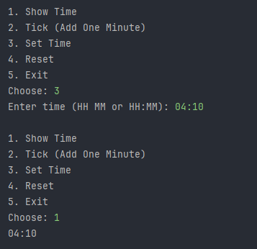

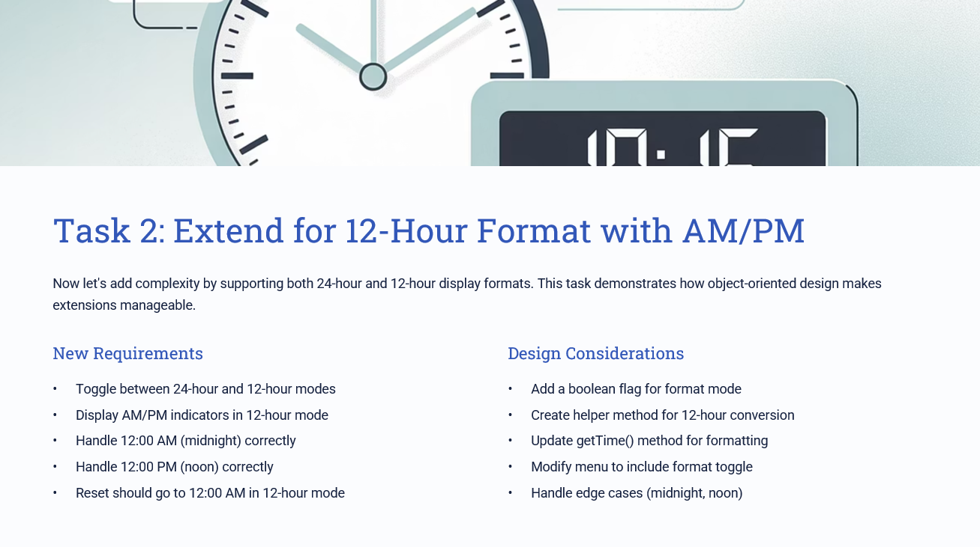
Code for Task 2
import java.util.Scanner;

public class Task2 {
private int hour;
private int minute;
private boolean is24HourMode;

public Task2() {
hour = 0;
minute = 0;
is24HourMode = true;
}

public void showTime() {
if (is24HourMode) {
System.out.printf("%02d:%02d%n", hour, minute);
} else {
int displayHour = hour % 12;
if (displayHour == 0) displayHour = 12;
String amPm = hour < 12 ? "AM" : "PM";
System.out.printf("%02d:%02d %s%n", displayHour, minute, amPm);
}
}

public void tick() {
minute++;
if (minute >= 60) {
minute = 0;
hour++;
if (hour >= 24) hour = 0;
}
}

public void setTime(int h, int m) {
if (h >= 0 && h < 24 && m >= 0 && m < 60) {
hour = h;
minute = m;
} else {
System.out.println("Invalid time values.");
}
}

public void reset() {
if (is24HourMode) {
hour = 0;
} else {
hour = 0; // 12:00 AM in 12-hour mode
}
minute = 0;
}

public void toggleFormat() {
is24HourMode = !is24HourMode;
System.out.println(is24HourMode ? "Switched to 24-hour mode." : "Switched to 12-hour mode.");
}

public static void main(String[] args) {
Scanner sc = new Scanner(System.in);
Task2 clock = new Task2();

while (true) {
System.out.println("\n1. Show Time");
System.out.println("2. Tick (Add One Minute)");
System.out.println("3. Set Time");
System.out.println("4. Reset");
System.out.println("5. Toggle Format (12H/24H)");
System.out.println("6. Exit");
System.out.print("Choose: ");

int choice;
try {
choice = Integer.parseInt(sc.nextLine());
} catch (Exception e) {
System.out.println("Invalid choice.");
continue;
}

if (choice == 1) {
clock.showTime();
} else if (choice == 2) {
clock.tick();
clock.showTime();
} else if (choice == 3) {
System.out.print("Enter time (HH MM or HH:MM): ");
String input = sc.nextLine().trim();
int h, m;
try {
if (input.contains(":")) {
String[] parts = input.split(":");
h = Integer.parseInt(parts[0]);
m = Integer.parseInt(parts[1]);
} else {
String[] parts = input.split(" ");
h = Integer.parseInt(parts[0]);
m = Integer.parseInt(parts[1]);
}
clock.setTime(h, m);
} catch (Exception e) {
System.out.println("Invalid format.");
}
} else if (choice == 4) {
clock.reset();
System.out.println("Clock reset.");
} else if (choice == 5) {
clock.toggleFormat();
} else if (choice == 6) {
break;
} else {
System.out.println("Invalid choice.");
}
}
}
}

Screendshot
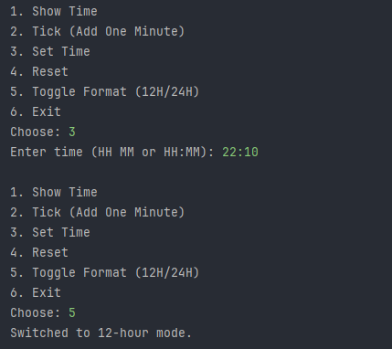
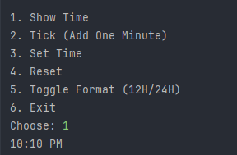
Conclusion

In this lab, we learned how to build and extend a digital clock using Java. In the first task, we created a basic 24-hour clock that could show time, increase minutes with each tick, allow users to set a specific time, and reset the clock back to 00:00. This helped us understand how time calculation works using simple arithmetic and conditional checks.

In the second task, we improved the same clock to support both 24-hour and 12-hour formats with AM and PM indicators. We added a toggle option so users could switch between the two modes anytime. The program also handled special cases like midnight (12:00 AM) and noon (12:00 PM) correctly. Through this, we practiced how to extend an existing program by adding new features without breaking its original logic.

Overall, these tasks helped us understand object-oriented thinking, method usage, user input handling, and how to make small but meaningful improvements to a program design.

